# **Exoplanets**

On average, it is estimated that there is at least one planet for every star in the galaxy. That means there's something on the order of billions of planets in our galaxy alone, many in Earth's size range. These planets outside of our solar system are known as Exoplanets.

Most of the exoplanets discovered so far are in a relatively small region of our galaxy, the Milky Way. ("Small" meaning within thousands of light-years of our solar system; one light-year equals 5.88 trillion miles, or 9.46 trillion kilometers.) Even the closest known exoplanet to Earth, [**Proxima Centauri b**](https://science.nasa.gov/exoplanet-catalog/proxima-centauri-b/), is still about 4 light-years away. We know there are more planets than stars in the galaxy.

By measuring exoplanets’ sizes (diameters) and masses (weights), we can see compositions ranging from rocky (like Earth and Venus) to gas-rich (like Jupiter and Saturn). Some planets may be dominated by water or ice, while others are dominated by iron or carbon. We’ve identified [**lava worlds**](https://science.nasa.gov/exoplanet-catalog/55-cancri-b/) covered in molten seas, puffy planets the [**density of Styrofoam**](https://science.nasa.gov/exoplanet-catalog/kepler-7b/) and dense [**cores of planets**](https://science.nasa.gov/exoplanet-catalog/psr-b125712-b/) still orbiting their stars.

<https://eyes.nasa.gov/apps/exo/#/>

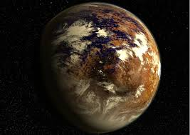

[**Proxima Centauri b**](https://science.nasa.gov/exoplanet-catalog/proxima-centauri-b/)

<https://exoplanets.nasa.gov/gltf_embed/2211/?height=450&amp;rotate=true&amp;cc=true&amp;fs=true&amp;target=&amp;orbit=>

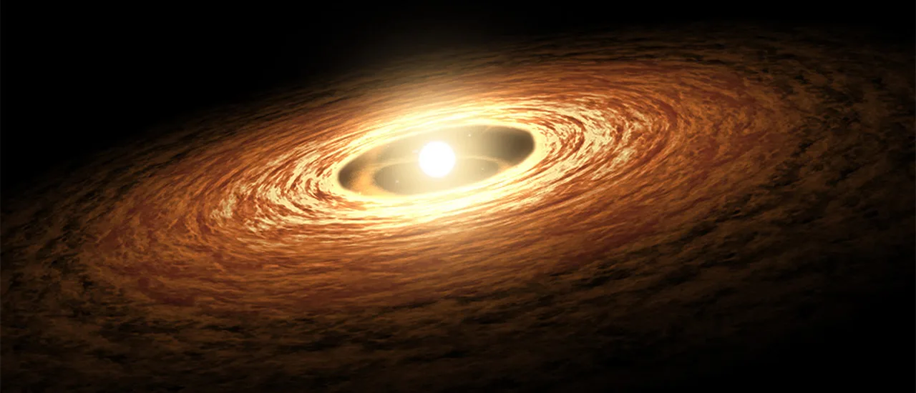

# **What is an Exoplanet?**

The planets beyond our solar system are called “exoplanets,” and they come in a wide variety of sizes, from gas giants larger than Jupiter to small, rocky planets about as big around as Earth or Mars. They can be hot enough to boil metal or locked in deep freeze. They can orbit their stars so tightly that a “year” lasts only a few days; they can orbit two suns at once. Some exoplanets are sunless rogues, wandering through the galaxy in permanent darkness.

<https://youtu.be/k1UcseLVNVc>

## **Types of exoplanets**

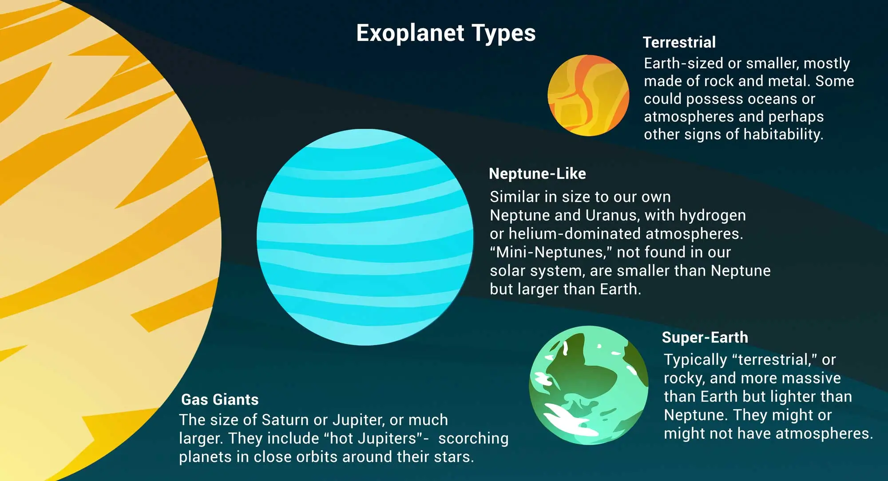

[Gas giants](https://exoplanets.nasa.gov/what-is-an-exoplanet/planet-types/gas-giant/) are planets the size of Saturn or Jupiter, the largest planet in our solar system, or much, much larger.

More variety is hidden within these broad categories. Hot Jupiters, for instance, were among the first planet types found – gas giants orbiting so closely to their stars that their temperatures soar into the thousands of degrees (Fahrenheit or Celsius).

[Neptunian planets](https://exoplanets.nasa.gov/what-is-an-exoplanet/planet-types/neptune-like/) are similar in size to Neptune or Uranus in our solar system. They likely have a mixture of interior compositions, but all will have hydrogen and helium-dominated outer atmospheres and rocky cores. We’re also discovering mini-Neptunes, planets smaller than Neptune and bigger than Earth. No planets of this size or type exist in our solar system.

[Super-Earths](https://exoplanets.nasa.gov/what-is-an-exoplanet/planet-types/super-earth/) are typically terrestrial planets that may or may not have atmospheres. They are more massive than Earth, but lighter than Neptune.

[Terrestrial planets](https://exoplanets.nasa.gov/what-is-an-exoplanet/planet-types/terrestrial/) are Earth sized and smaller, composed of rock, silicate, water or carbon. Further investigation will determine whether some of them possess atmospheres, oceans or other signs of habitability.

Explore the planet types: [Gas Giant](https://exoplanets.nasa.gov/what-is-an-exoplanet/planet-types/gas-giant/), [Neptune-like](https://exoplanets.nasa.gov/what-is-an-exoplanet/planet-types/neptune-like/), [Super-Earth](https://exoplanets.nasa.gov/what-is-an-exoplanet/planet-types/super-earth/) and [Terrestrial](https://exoplanets.nasa.gov/what-is-an-exoplanet/planet-types/terrestrial/)

Or move on to [the building blocks of galaxies: stars!](https://exoplanets.nasa.gov/what-is-an-exoplanet/stars)

# **Are We Alone?**

### **The search for life beyond Earth is really just getting started, but science has an encouraging early answer: there are plenty of planets in the galaxy, many with similarities to our own. But what we don’t know fills volumes.**

Observations from the ground and from space have confirmed [thousands of planets beyond our solar system](https://exoplanets.nasa.gov/discovery). Our galaxy likely holds trillions. But so far, we have no evidence of life beyond Earth. Is life in the cosmos easily begun, and commonplace? Or [is it incredibly rare?](https://science.nasa.gov/universe/exoplanets/is-earth-an-oddball/)

<https://youtu.be/MX3PIkbTQwQ>

## **Where is everybody?**

The universe's eerie silence has its own name – the ["Fermi paradox."](https://www.nasa.gov/feature/nasa-is-taking-a-new-look-at-searching-for-life-beyond-earth) Physicist Enrico Fermi famously posed the question: "Where is everybody?" Even at slow travel speeds, the universe's billions of years of existence allow plenty of time for intelligent, technological lifeforms to traverse the galaxy. Why, then, is the cosmos so quiet?

Meanwhile, exoplanet discoveries over the past two decades have filled in a few of the terms in the much-debated [Drake Equation](https://science.nasa.gov/universe/exoplanets/are-we-alone-in-the-universe-revisiting-the-drake-equation/) – a chain of numbers that might one day tell us how many intelligent civilizations we can expect to find. Most of its terms remain blank – the fraction of planets with life, with intelligent life, with detectable technology – but the equation itself suggests we might one day arrive at an answer. It feels at least a little more hopeful than Fermi's silence.

We stand at a crossroads in the search for life. We've found thousands of planets in our Milky Way galaxy, a large fraction of them in Earth's size range and orbiting in their stars' "habitable zones" – the distance from the star at which liquid water *could* exist on the surface. We know the galaxy likely holds trillions of planets. Our telescopes in space and on the ground, and our remote-sensing technology, grow ever more powerful. Yet so far, the only life we know of is right here at home. For the moment, we're staring into the void, hoping someone is staring back.

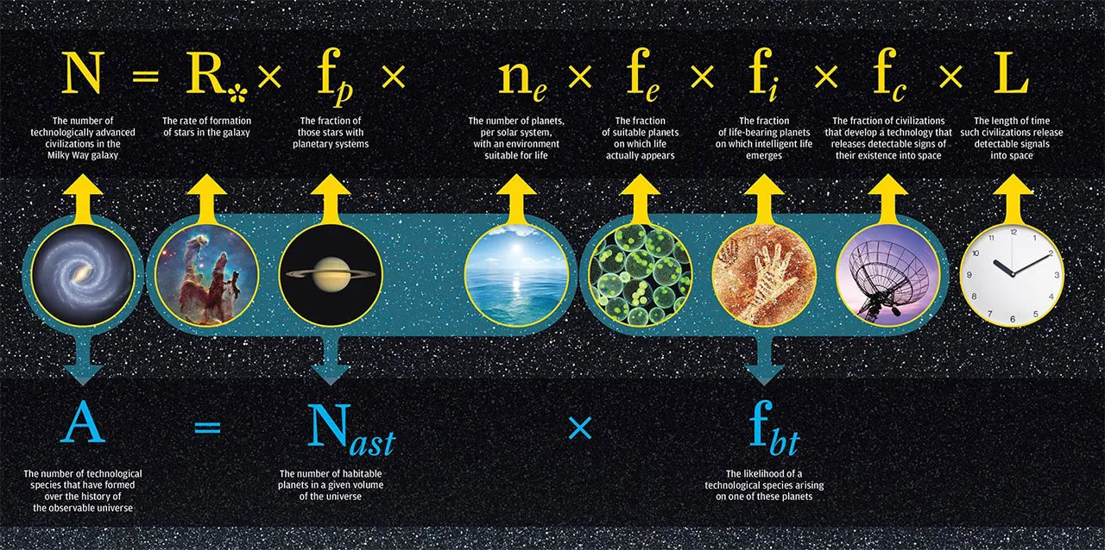

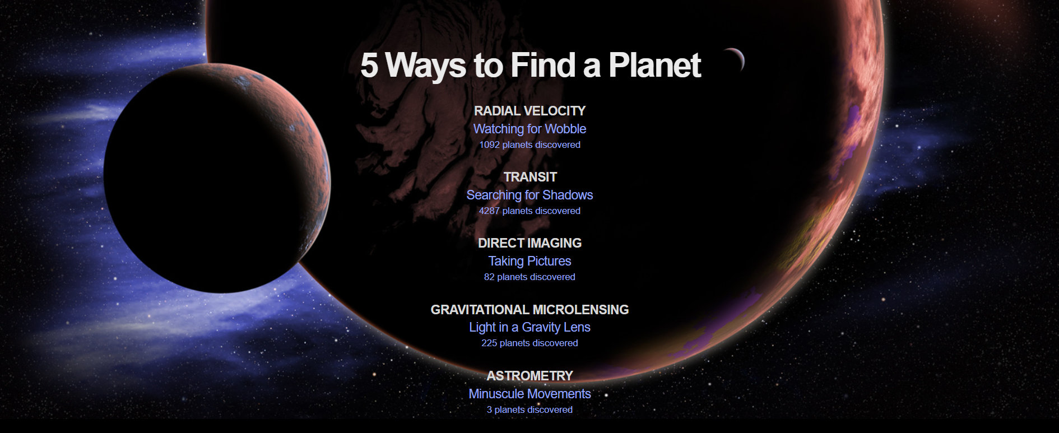

## **How Do We Name Exoplanets?**

Exoplanet names can look long and complicated at first, especially when compared to names like Venus and Mars. However, there is a logic behind their naming system that is important to how scientists catalog thousands of planets. Astronomers differentiate between the alphanumeric "designations" and alphabetical "proper names." All stars and exoplanets have designations, but very few have proper names.

The first part of an exoplanet name is usually the telescope or survey that discovered it. The number is the order in which the star was cataloged by position. The lowercase letter stands for the planet, in the order in which the planet was found. The first planet found is always named b, with ensuing planets named c, d, e, f and so on. The star that the exoplanet orbits is usually the undeclared "A" of the system, which can be useful if the system contains many stars, which themselves may be designated B or C. (Stars get capital letters; planets receive lowercase designations.) If a bunch of exoplanets around the same star are found at once, the planet closest to its star is named b with more distant planets named c, d, e and so on.

An example of an exoplanet name is Kepler-16b, where "Kepler" is the name of the telescope that observed the system, 16 is the order in which the star was cataloged and "b" is the closest planet to the star. If we were naming Earth as an exoplanet, it would be called Sun d (Sun is the name of our star, and Earth is the third planet, starting with b, Mercury).

**Famous exoplanets**

51 Pegasi b

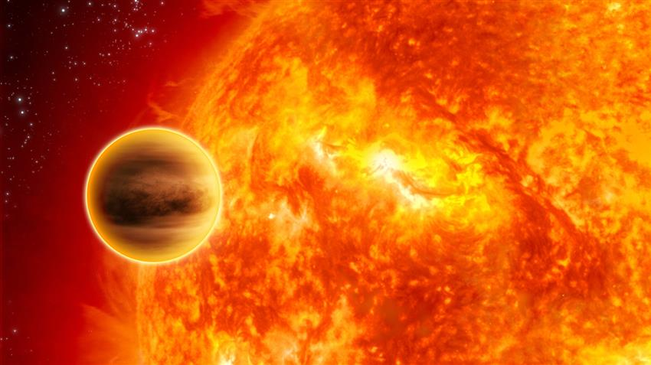

51 Pegasi b was the first exoplanet ever discovered orbiting a star that resembles our Sun. Also the first Hot Jupiter ever observed, this gas giant located 50 light-years from Earth takes only 4.2 days to orbit its star.

51 Pegasi b's discovery in 1995 by Swiss astronomers Michel Mayor and Didier Queloz surprised the scientific community since models of planetary formation at the time did not predict its existence. The pair later won the Nobel Prize in Physics in 2019 for their achievement.

Kepler-22b

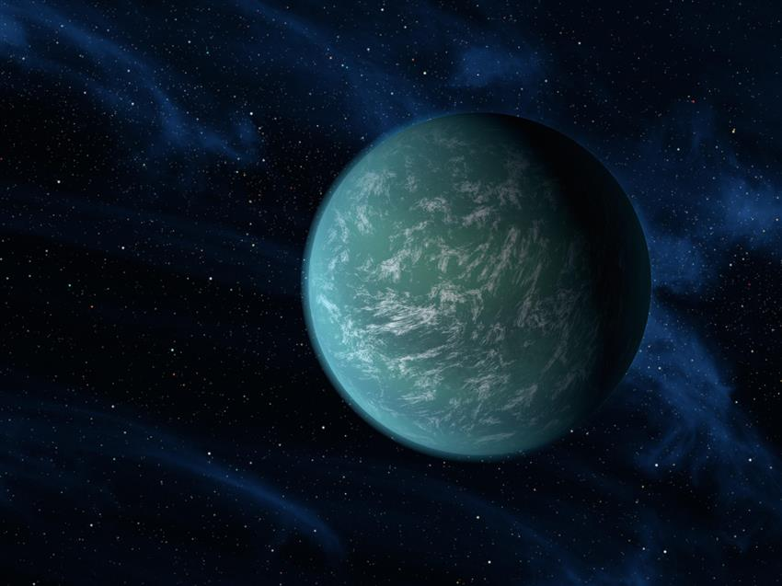

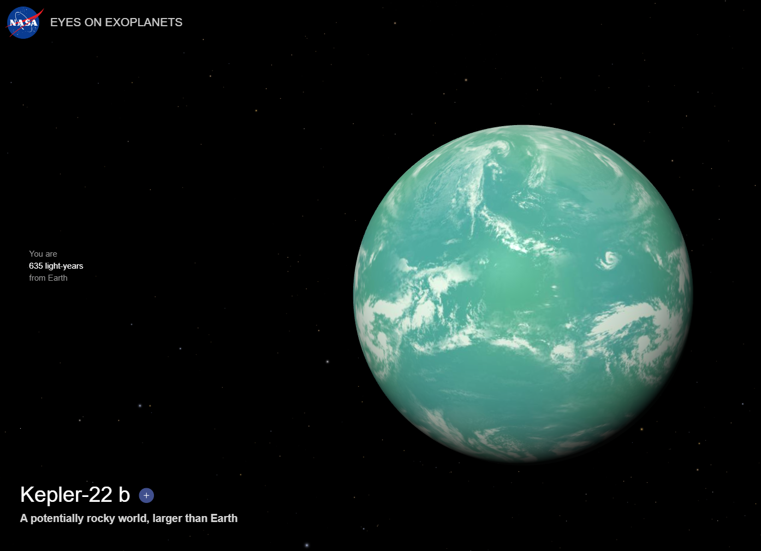

Roughly twice the size of Earth, Kepler-22b was discovered in 2011 by NASA's Kepler Space Telescope. The exoplanet was the first to be found in any star's habitable zone.

Although scientists are unsure what Kepler-22b looks like, the exoplanet orbits its star at just the right distance – where a planet is most likely to have a climate that would allow any water on its surface to remain liquid.

This area is also called the Goldilocks Zone, since the conditions are not too hot, not too cold, but just right. However, there are no guarantees that this exoplanet, located about 600 light-years away from Earth, hosts alien life, or that humans could live on it.

Proxima Centauri b

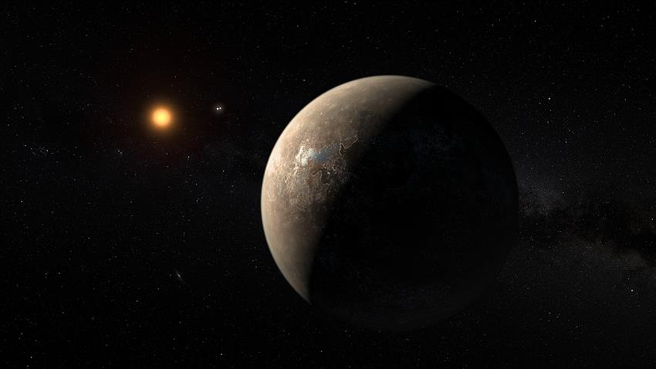

Proxima Centauri is the closest star to the Sun. This red dwarf star is located 4.2 light-years – or 40 trillion kilometres – away from Earth. An exoplanet, Proxima Centauri b, was detected orbiting this star in 2016.

Proxima Centauri b is a rocky planet that is a bit larger than Earth. Like Kepler-22b, it is also located in its star's habitable zone. Scientists find this exoplanet very intriguing, but they will have to continue studying it from afar – even using the fastest space probe ever built, the Parker Solar Probe which could travel at speeds of up to 724,000 km/h, it would take almost 7000 years to reach Proxima Centauri b!

In 2020, scientists confirmed the existence of a second planet in this system: Proxima Centauri c. This super-Earth or mini-Neptune is about 7 times as massive as our planet, but orbits its star beyond the habitable zone.

**Objectives**

Your challenge is to develop innovative solutions that leverage creativity to enlighten students about the wonders of exoplanets. Can you create a valuable experience for students that facilitates visualization and learning about exoplanets? Think about how your project could expand the horizons of education and exploration, transforming complex scientific concepts into engaging and accessible learning materials and interactive tools.

What would be the most effective way to communicate this information to your audience? Whether through immersive virtual reality (VR) experiences, interactive storytelling, or dynamic visualizations, you can use this opportunity to explore the intersection of science and art while inspiring curiosity about the universe. Diverse ideas are welcome, so don’t necessarily limit your project to an educational package or tool.

You could dive into data science and machine learning to uncover hidden patterns, reveal the range of exoplanet diversity, and craft interactive experiences that inspire curiosity and ignite imaginations. Think about how you might harness different tools, potentially including AI algorithms, to generate captivating visualizations of these distant worlds, analyze datasets of exoplanet observations, and classify different types of exoplanets.

By leveraging your creativity, educational tools, interactive simulations, and multimedia resources, you can create dynamic and immersive learning experiences that inspire curiosity and empower learners to explore the wonders of exoplanet research. When students use your project to explore these distant worlds, they will not only expand their scientific knowledge, but also deepen their appreciation for the wonders of the universe and their place within it.

**Exploratory data Analysis on NASA Exoplanet Archive data**

**Data Source:**

<https://exoplanetarchive.ipac.caltech.edu/cgi-bin/TblView/nph-tblView?app=ExoTbls&config=PS>

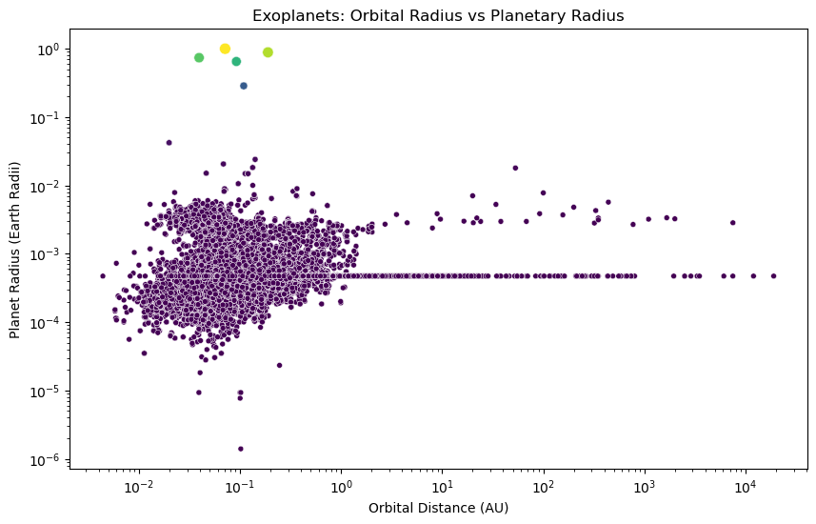

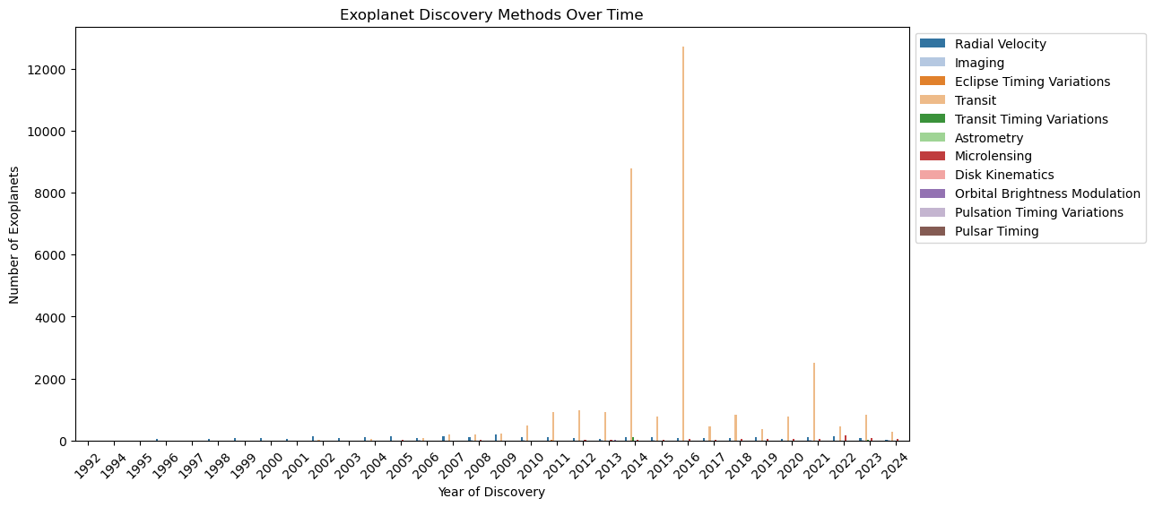

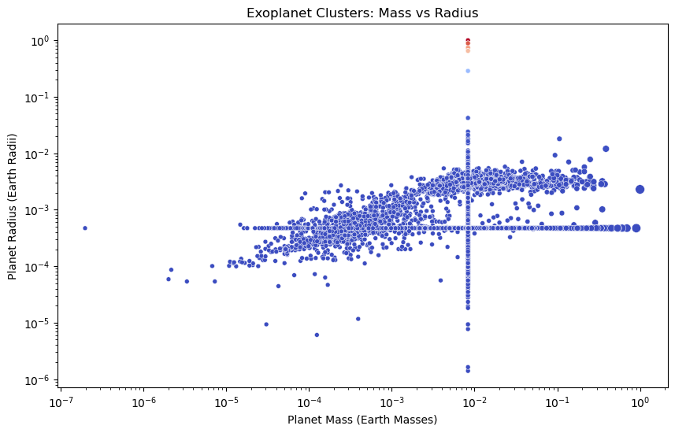

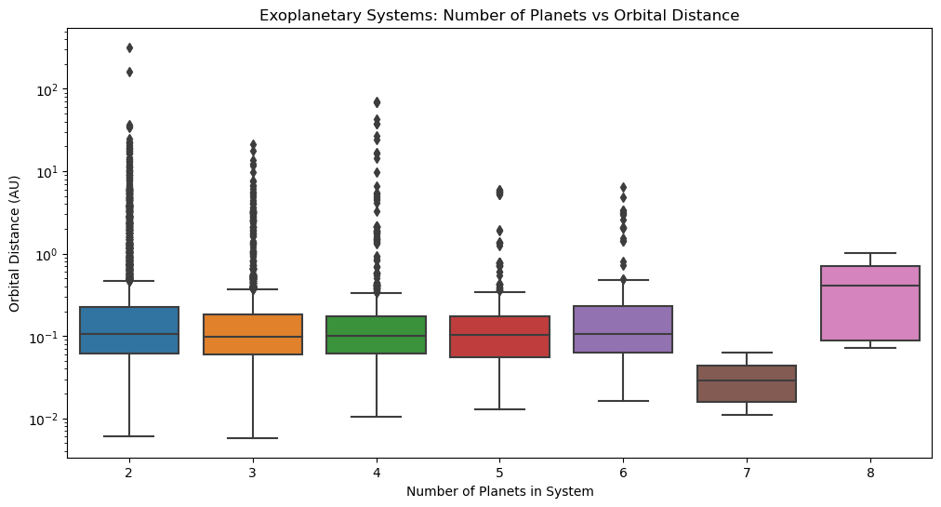

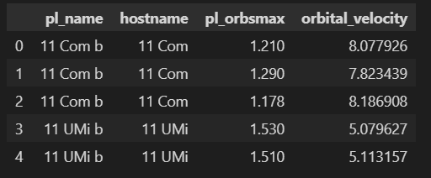

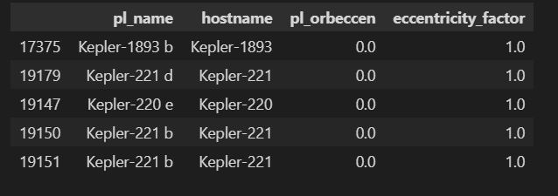

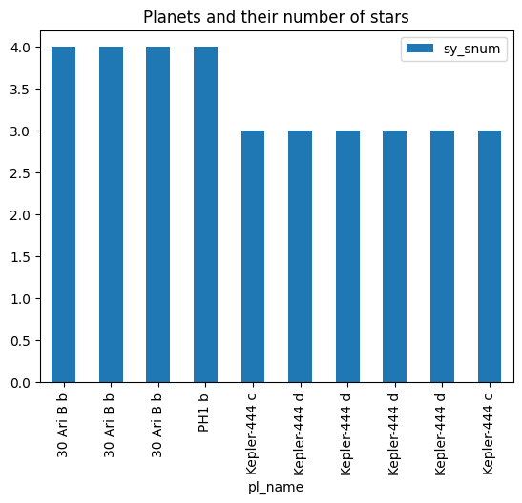

How Planet discovered ?

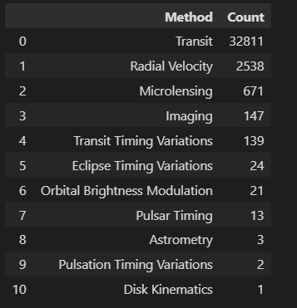

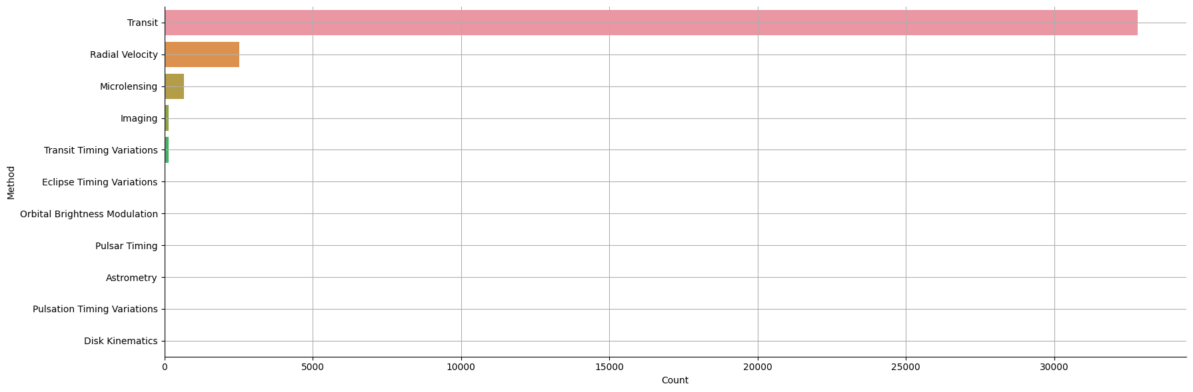

Discovery of exoplanets each year



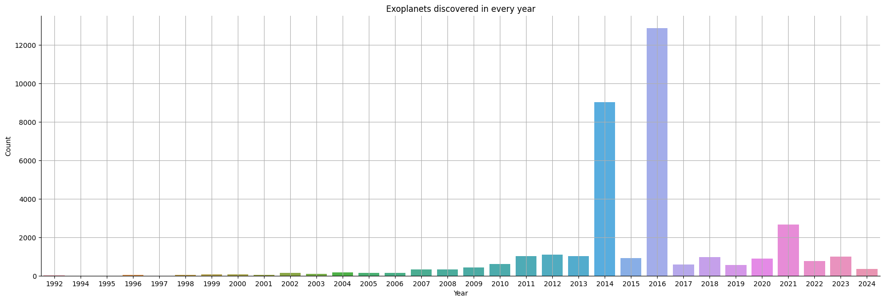

**Facilities used for the discovery**

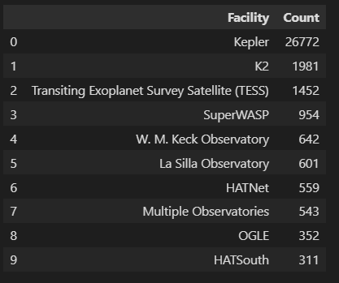

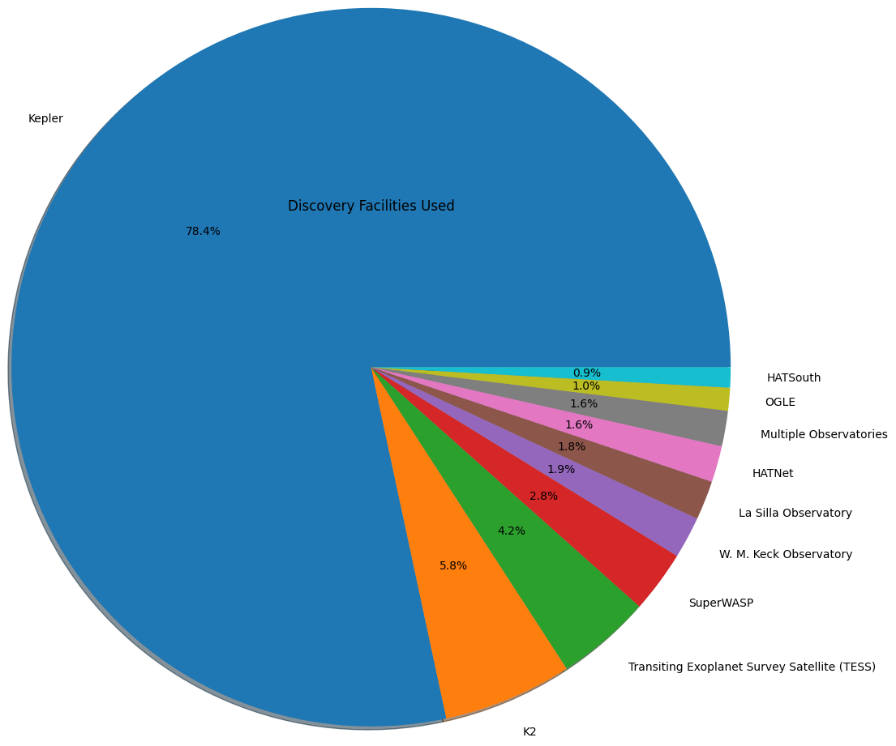

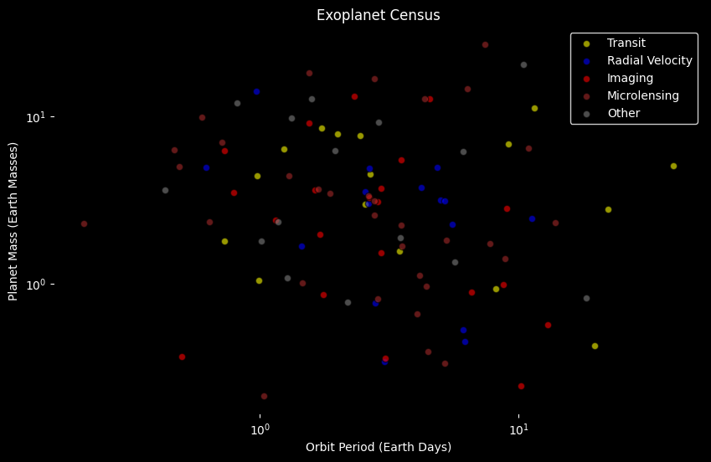

**Confirmed Planets**

